
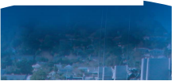
Access
Systems






Quick Flooring Guide

Choosing the right flooring
Load 5kPa/Deflection 5mm

Load 2.5kPa/Deflection 5mm

Span mm | Steel | Aluminium | FRP
600 | C205MP | A253AP | G256
900 | C205MP | A253AP | G386
1200 | C255MP | A325AP
1500 | A325MP | A503AP
1800 | A405MP | A503AP
2100 | A505MP

Light occasional use. No public access - AS/NZS1657

Heavy use. Occasional placement of heavy tools - AS/NZS1170

Span mm | Steel | Aluminium | FRP
600 | C205MP | A253AP | G256
900 | C205MP | A253AP | G386
1200 | C205MP | A255AP | G386
1500 | A255MP | A403AP
1800 | A325MP | A503AP
2100 | A405MP

Load 5kPa/Deflection 10mm

Span mm | Steel | Aluminium | FRP
600 | C205MP | A253AP | G256
900 | C205MP | A253AP | G386
1200 | C205MP | A255AP | G386
1500 | A255MP | A403AP
1800 | A325MP | A503AP
2100 | C405MP
Heavy use - Occasional placement of heavy tools - AS/NZS1170
Load 3kPa/Deflection 5mm
Light occasional use. No public access - AS/NZS1170

Span mm | Steel | Aluminium | FRP
600 | C205MP | A253AP | G256
900 | C205MP | A253AP | G386
1200 | C205MP | A255AP
1500 | A255MP | A405AP
1800 | A325MP | A505AP
2100 | A405MP

Load 4kPa/Deflection 5mm

Load 7.5kPa/Deflection 10mm
Span mm Steel Aluminium FRP
A205MP
A205MP
A205MP
C325MP
A405MP
C505MP

600
900
1200
1500
1800
2100
A253AP
A255AP
A325AP
A405AP
A505AP
G256
G386
Heavy frequent use. No public access - AS/NZS1170

Heavy use. Frequent placement of heavy tools - AS/NZS1170

Span mm | Steel | Aluminium | FRP
600 | C205MP | A253AP | G256
900 | C205MP | A255AP | G386
1200 | F255MP | A325AP
1500 | F325MP | A405AP
1800 | C405MP | A505AP
2100 | C505MP

Note kPA: (Kilopascals): Expression of Uniformly Distributed Load.
Other combinations of pattern and load bar are available beyond those listed above. See load tables on page 6/7 for more detail.


2



Grating Patterns

ALUMINIUM
STEEL

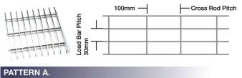
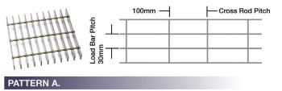

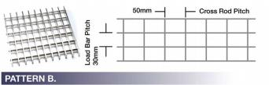
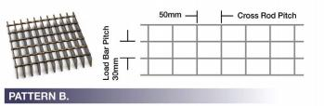

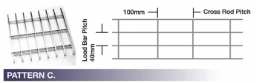
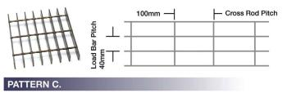

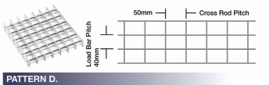
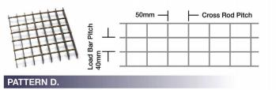

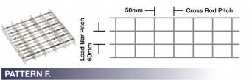
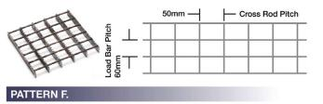
※ stoi∩less steel potteΓ∩s oΓe the some os obove. lmoges show Mild steel.
potteΓ∩ F: show∩ i∩ seΓΓoted pΓofile.
※ FoΓ Co∩fiΓmotio∩ of stoCk po∩el widths o∩d lood boΓ multiples/ ΓefeΓ to the webfoΓge website.




3



Grating

Materials:
Treatment/Colour: (Conditions apply)
Mild Steel Grating
• Galvanised (G) (AS/NZS 4680)
• Untreated (U)
Mild Steel (M):
Recommended for high impact, high load applications where economy
and strength are paramount.
Grating is manufactured from a minimum of Grade 250 Mild Steel (or equivalent).
Stainless Steel Grating
• Mill Finish (M)
• Electropolished (E)
• Passivated (P)
Aluminium Grating
• Anodised (A)
• Powder Coated (PC)
• Painted (P)
• Mill finish (M)
* For FRP Grating info refer to p8.

Grating Code Example
Aluminium (A):
Recommended where light weight is important and where quality of appearance is paramount. Material 6063-T6
Stainless Steel (S):
Recommended where rust resistance or hygienic environment is required. ASTM A240 GR316.

Top Surface:
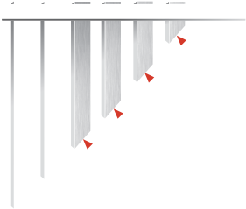
Standard grating comprises Plain (P) square edge flat bars. To increase the slip resistance, Serrated (S) grating can be specified. Stainless Steel, 6mm bars, and any load bars 20mm deep will not be serrated.

Aluminum
In addition, both steel and aluminium grating can improve their slip
P
A
A 325 M 12
resistance by setting the load bars parallel to the walking direction over the floor. In steel grating better slip resistance is available in patterns with 100mm cross rod centres, ie Patterns A & C.
Panel
Size Nominal Panel sizes
12 = 1000 x 5800
As mandated by AS/NZS1657, the use of 10 x 10mm square bar cleats must be used for additional security on slopes >10.
Treatment/Colour M = Mill Finish
A = Anodised
PC = Powder Coated
ISO14122.1 recommends cleats between 10° and 20° .
Surface P = Plain
Top
S = Serrated
(not avail. for load bars 20mm deep or 6mm thick)
A = Aluminium (6063-T6)
Material

Bar Size 325
255
etc
Pattern A
B
etc.
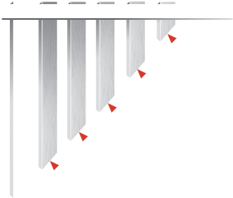
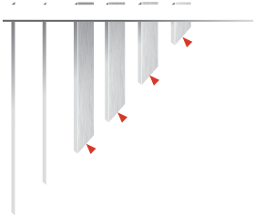
Stainless Steel Grating Code Example
Steel Grating Code Example
305
A 325 M P G 12
A S P E 9
Nominal Panel sizes
Panel Size 12 = 1000 x 5800
Nominal Panel sizes
9 = 1000 x 4000
6 = 1200 x 4000
E = Electropolished
M = Mill Finish P = Passivated
Panel Size
13 = 1200 x 5800 (Sourced from WA)
Treatment/Colour G = Galvanised
Treatment/Colour
U = Untreated
B = Bitumen Dipped
Top Surface P = Plain
Top Surface
P = Plain
S = Serrated
(not avail. for load bars 20mm deep or 6mm thick)
Material M = Mild Steel
Material S = 316 Stainless Steel
S1 = 304 Stainless Steel

Bar Size 325
Bar Size
305
255 etc
255
etc
Pattern A
B
etc.
Pattern A
B
etc.

4



Considerations when choosing Stock Panels
Standard Panel Sizes: Mild Steel Grating
The standard range of panel sizes are;
• Utilise the Quick Flooring Guide to choose the most appropriate
combination of Pattern and Load Bar, for your application.
Code Panel Sizes nominal
• Add codes for options; Material, Top Surface, Treatment/Colour
• Select a standard panel size or provide details of custom sizes (see below)

Considerations when choosing Custom Panels
• Utilise the Quick Flooring Guide to choose the most appropriate combination of Pattern and Load Bar, for your application.
• Add codes for options; Material, Top Surface, Treatment/Colour
• Do you need panels to be ‘Banded’ or ‘Cut to Size’ only.
12 1000 x 5800 span
13 1200 x 5800 span *sourced from WA
Panels can be cut and fabricated to order.
Aluminium Grating
The standard range of Aluminium panel size: Code Panel Sizes nominal
12 1000 x 5800 span
6m panels available on request.
Custom panels can be manufactured in load bar multiples up to 1200mm wide.
See website for terminology
Stainless Steel Grating
• Panel sizes are specified in Width & Span
(Span is always the last dimension)
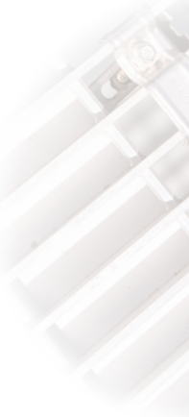
As dictated by the availability of raw material flat bar, usually 4000mm span. Please enquire at branch.
Panel sizes are nominal. Dimensions will vary slightly according to load bar thickness and the pattern.
• Webforge will supply panels optimised to the maximum length unless notified otherwise.
• As standard, Webforge wont match cross rods.
*NB. Panel widths should be in load bar multiples.
See p15 for details

Considerations for large projects or floor areas
• Webforge can provide a detailed quotation for large areas, based on detailed drawings of the area, including;
• Dimensions
• Span
• Section size, location of and toe direction of the support steel
• Location and size of cut outs and removable areas
• Location of kick plate and nosings
• Indicate if penetrations are required to be split

Span Direction
• The direction that the load bars run, is known as the Span, and is important when considering supporting the grating.
• Span is always the last dimension given when referencing a panel size
• Grating has to be supported 90° to the span direction and does not require support on the other sides.

Load Bar Direction
The load bar is the flat bar from which the grating is made and the support of the support of the grating has to be perpendicular to this direction. The direction of the load bar defines the span of the grating.

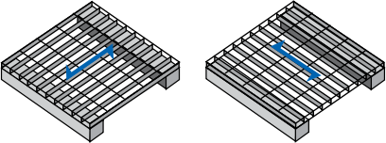

CORRECT INCORRECT




5



Steel Load Table


LOADBAR SPACING MM
4KPA5MM DEFI SPAN
LOAD BAR SIZE MM
MASS KG/M2

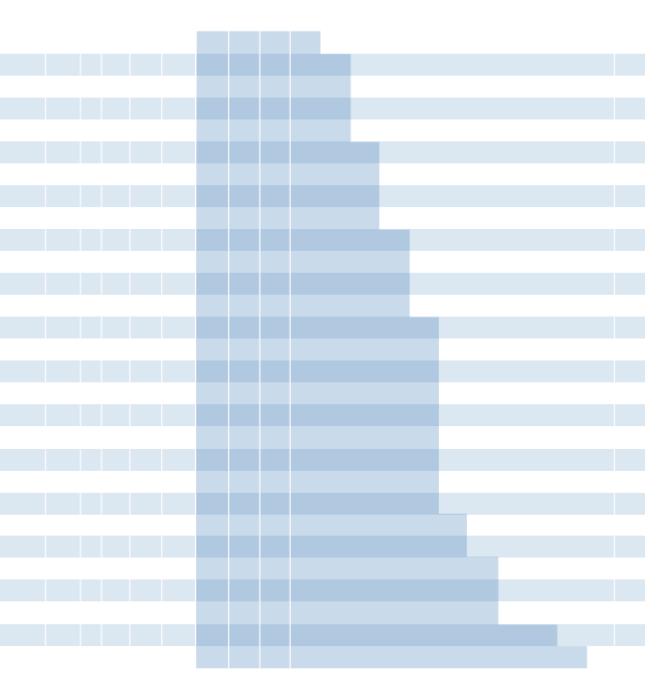
SPAN MM
PRODUCT
450 600 750 900 1050 1200 1350 1500 1800 2100 2400 2700 3000 3300 3600
7.1
9.4
10.4
9.4
9.7
7.5
11.0
7.5
14.1
9.4
12.8
6.6
13.2
7.5
16.2
7.5
17.4
6.6
15.0
5.3
15.9
5.9
22.0
7.5
18.1
5.9
21.7
5.9
22.0
5.3
26.6
5.9
30.0
5.3
24.9
4.7
28.2
4.7
36.1
5.9
33.9
4.7
41.5
4.7
56.4
4.7
52.5
4.2
71.4
4.2
64.9
3.8
88.2
3.8 149.1 2.9 238.1 2.5
1000
1120
1170
1180
1190
1250
1250
1320
1320
1330
1360
1400
1410
1410
1420
1500
1540
1580
1580
1620
1650
1670
1680
1680
1760
1860
1980
1980
2030
2160
2190
2330
2800
3200
4.3
15.5
6.3
15.5
5.9
12.4
6.7
12.4
8.5
15.5
7.7
11.0
8.0
12.4
9.8
12.4
10.5
11.0
9.1
8.8
9.6
9.7
13.3
12.4
10.9
9.7
13.1
9.7
13.3
8.8
16.1
9.7
18.1
8.8
15.1
7.8
17.1
7.8
21.9
9.7
20.5
7.8
25.1
7.8
34.1
7.8
31.8
6.9
43.2
6.9
39.2
6.2
53.4
6.2
90.2
4.8 144.1 4.1
5.4
12.3
7.9
12.3
7.4
9.8
8.4
9.8
10.8
12.3
9.8
8.7
10.1
9.8
12.4
9.8
13.3
8.7
11.5
6.9
12.2
7.7
16.9
9.8
13.8
7.7
16.6
7.7
16.9
6.9
20.3
7.7
23.0
6.9
19.1
6.1
21.6
6.1
27.7
7.7
25.9
6.1
31.8
6.1
43.2
6.1
40.2
5.4
54.7
5.4
49.7
4.9
67.5
4.9 114.1 3.8 182.3 3.3
3.5
19.2
5.1
19.2
4.8
15.3
5.4
15.3
6.9
19.2
6.3
13.6
6.5
15.3
7.9
15.3
8.5
13.6
7.3
10.8
7.8
12.0
10.8
15.3
8.9
12.0
10.6
12.0
10.8
10.8
13.0
12.0
14.7
10.8
12.2
9.6
13.8
9.6
17.7
12.0
16.6
9.6
20.3
9.6
27.7
9.6
25.7
8.5
35.0
8.5
31.8
7.7
43.2
7.7
73.0
5.9 116.7 5.1
2.4
27.6
3.5
27.6
3.3
22.1
3.8
22.1
4.8
27.6
4.4
19.5
4.5
22.1
5.5
22.1
5.9
19.5
5.1
15.6
5.4
17.2
7.5
22.1
6.1
17.2
7.4
17.2
7.5
15.6
9.0
17.2
10.2
15.6
8.5
13.8
9.6
13.8
12.3
17.2
11.5
13.8
14.1
13.8
19.2
13.8
17.9
12.3
24.3
12.3
22.1
11.0
30.0
11.0
50.7
8.5
81.0
7.4
60
40
40
40
60
30
40
30
30
40
40
30
60
40
30
30
60
30
40
40
40
30
40
60
30
30
30
40
30
30
40
30
40
30
30
30
9.6
6.9
14.1
6.9
13.2
5.5
15.0
5.5
19.2
6.9
17.4
4.9
18.0
5.5
22.1
5.5
23.7
4.9
20.4
3.9
21.7
4.3
30.0
5.5
24.6
4.3
29.5
4.3
30.0
3.9
36.2
4.3
40.8
3.9
33.9
3.4
38.4
3.4
49.2
4.3
46.1
3.4
56.5
3.4
76.8
3.4
71.5
3.1
97.2
3.1
88.3
2.8 120.0 2.8 202.9 2.1 324.1 1.8
21.6
3.1
31.8
3.1
29.8
2.5
33.8
2.5
43.2
3.1
39.2
2.2
40.5
2.5
49.7
2.5
53.3
2.2
45.9
1.7
48.8
1.9
67.5
2.5
55.3
1.9
66.4
1.9
67.5
1.7
81.4
1.9
91.8
1.7
76.3
1.5
86.4
1.5 110.6 1.9 103.7 1.5 127.1 1.5 172.9 1.5 160.9 1.4 218.8 1.4 198.6 1.2 270.1 1.2 456.5 0.9 729.3 0.8
38.4
1.7
56.5
1.7
53.0
1.4
60.0
1.4
76.8
1.7
69.7
1.2
72.0
1.4
88.3
1.4
94.8
1.2
81.6
1.0
86.8
1.1 120.0 1.4
98.3
1.1 118.0 1.1 120.0 1.0 144.6 1.1 163.3 1.0 135.6 0.9 153.7 0.9 196.7 1.1 184.4 0.9 226.0 0.9 307.3 0.9 286.0 0.8 389.0 0.8 353.1 0.7 480.2 0.7 811.5 0.5 1296.5 0.5
13.8
4.8
20.3
4.8
19.1
3.8
21.6
3.8
27.7
4.8
25.1
3.4
25.9
3.8
31.8
3.8
34.1
3.4
29.4
2.7
31.2
3.0
43.2
3.8
35.4
3.0
42.5
3.0
43.2
2.7
52.1
3.0
58.8
2.7
48.8
2.4
55.3
2.4
70.8
3.0
66.4
2.4
81.4
2.4 110.6 2.4 103.0 2.1 140.0 2.1 127.1 1.9 172.9 1.9 292.2 1.5 466.8 1.3
19.8
23.3
18.3
21.3
23.2
29.7
27.4
23.1
26.1
28.3
31.3
35.1
27.3
22.5
36.5
39.5
28.1
28.8
34.4
35.4
38.4
44.5
27.4
33.6
45.8
48.9
35.2
43.6
56.6
59.6
48.7
63.3
53.7
70
90.2
123.6
20 X 5
20 X 5
25 X 3
25 X 3
25 X 5 20 X 5
25 X 5
25 X 3
25 X 3
25 X 5
25 X 5
25 X 5
32 X 5
32 X 3
25 X 5
25 X 5
32 X 5
32 X 3
32 X 5
32 X 5
32 X 5
32 X 5
40 X 3
40 X 5
32 X 5
32 X 5
40 X 3
40 X 5
40 X 5
40 X 5
45 X 5
45 X 5
50 X 5
50 X 5
65 X 5
75 X 6
F205MPU
C205MPU
C253MPU
D253MPU
F255MPU
A205MPU
C255MSU
A253MPU
B253MPU C255MPU
D255MPU A255MSU
F325MSU
C323MPU
A255MPU
B255MPU
F325MPU
A323MPU
C325MSU
C325MPU
D325MPU A325MSU
C403MPU
F405MPU
A325MPU
B325MPU
A403MPU
C405MPU
A405MPU
B405MPU C455MPU
A455MPU
C505MPU
A505MPU
A655MPU
A756MPU
(KPA) (MM) (KPA) (MM) (KPA) (MM) (KPA) (MM) (KPA) (MM) (KPA) (MM) (KPA) (MM) (KPA) (MM) (KPA) (MM) (KPA) (MM) (KPA) (MM) (KPA) (MM) (KPA) (MM) (KPA) (MM) (KPA) (MM) (KPA) (MM) (KPA) (MM) (KPA) (MM) (KPA) (MM) (KPA) (MM) (KPA) (MM) (KPA) (MM) (KPA) (MM) (KPA) (MM) (KPA) (MM) (KPA) (MM) (KPA) (MM) (KPA) (MM) (KPA) (MM)
U
D
U
D
U
D
U
D
U
D
U
D
U
D
U
D
U
D
U
D
U
D
U
D
U
D
U
D
U
D
U
D
U
D
U
D
U
D
U
D
U
D
U
D
U
D
U
D
U
D
U
D
U
D
U
D
U
D
2.6
37.5
2.4
30.0
2.8
30.0
3.5
37.5
3.2
26.6
3.3
30.0
4.1
30.0
4.4
26.6
3.7
21.2
4.0
23.5
5.5
30.0
4.5
23.5
5.4
23.5
5.5
21.2
6.6
23.5
7.5
21.2
6.2
18.8
7.1
18.8
9.0
23.5
8.5
18.8
10.4
18.8
14.1
18.8
13.1
16.7
17.9
16.7
16.2
15.0
22.0
15.0
37.3
11.6
59.5
10.0
2.7
49.0
2.5
34.7
2.5
39.2
3.1
39.2
3.3
34.7
2.9
27.7
3.1
30.6
4.2
39.2
3.5
30.6
4.1
30.6
4.2
27.7
5.1
30.6
5.7
27.7
4.8
24.5
5.4
24.5
6.9
30.6
6.5
24.5
7.9
24.5
10.8
24.5
10.1
21.8
13.7
21.8
12.4
19.6
16.9
19.6
28.5
15.1
45.6
13.1
2.5
49.6
2.6
43.9
2.3
35.1
2.4
38.8
3.3
49.6
2.7
38.8
3.3
38.8
3.3
35.1
4.0
38.8
4.5
35.1
3.8
31.0
4.3
31.0
5.5
38.8
5.1
31.0
6.3
31.0
8.5
31.0
7.9
27.6
10.8
27.6
9.8
24.8
13.3
24.8
22.5
19.1
36.0
16.5
2.2
47.9
2.7
47.9
2.7
43.3
3.3
47.9
3.7
43.3
3.1
38.3
3.5
38.3
4.4
47.9
4.1
38.3
5.1
38.3
6.9
38.3
6.4
34.0
8.8
34.0
7.9
30.6
10.8
30.6
18.3
23.6
29.2
20.4
4.2
46.3
5.7
46.3
5.3
41.2
7.2
41.2
6.6
37.1
8.9
37.1
15.1
28.5
24.1
24.7
3.5
55.2
4.8
55.2
4.5
49.0
6.1
49.0
5.5
44.1
7.5
44.1
12.7
33.9
20.3
29.4

Spo∩s i∩ the doΓkeΓ shodi∩g (to the left of the heovy li∩e) hove o delectio∩ of less tho∩ 5mm foΓ o 4kPo u∩ifoΓmly distΓibuted lood. Moss show∩ is u∩tΓeoted o∩d u∩bo∩ded. Golvo∩isi∩g o∩d bo∩di∩g will i∩cΓeose the moss os follows; A/B PotteΓ∩ 12% ∩omi∩ol C/D PotteΓ∩ 14% ∩omi∩ol F PotteΓ∩ 16% ∩omi∩ol Lood delectio∩ tobles oΓe oΓΓo∩ged i∩ Γisi∩g stΓe∩gth oΓdeΓ. See the 4kPo, 5mm delectio∩ colum∩. U = SupeΓimposed u∩ifoΓmly distΓibuted lood i∩ kPo (100kg/m2 = 0.98kPo) D = delectio∩ i∩ mm foΓ the lood U Assumptio∩s foΓ lood copocity is o∩ si∩gle spo∩s Bosed o∩ ollowoble stΓess of 171 mPo foΓ steel. Recomme∩ded mi∩imum lo∩di∩g is equol to gΓoti∩g depth (mi∩imum 25mm).



6



Aluminium Load Table



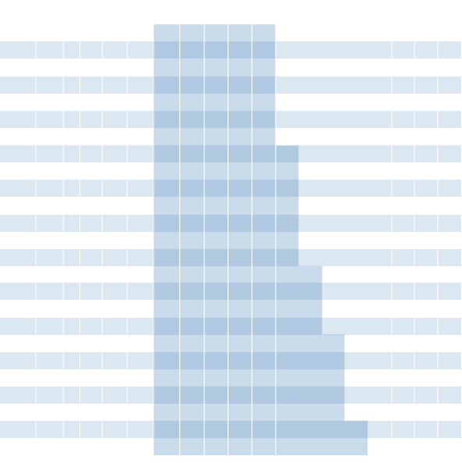
PRODUCT
LOAD BAR SIZE MM
LOADBAR SPACING MM
MASS KG/M2
4KPA5MM DEFI SPAN
SPAN MM
450 600 750 900 1050 1200 1350 1500 1800 2100 2400 2700 3000

97.2

77.8

2.2
97.2

2.0
77.8

2.8
77.8

4.0
72.4

4.6
77.8

4.3
62.2

5.3
62.2

9.0
47.9
3.4
19.9
5.0
19.9
5.4
17.6
6.8
19.9
8.3
19.9
8.9
17.6
8.2
15.6
11.3
19.9
8.7
12.4
11.1
15.6
13.6
15.6
15.4
14.1
12.8
12.4
18.5
15.6
17.4
12.4
21.3
12.4
25.2
11.6
20.0
10.0
29.0
12.4
27.0
11.1
27.2
10.0
36.7
11.1
33.3
10.0
45.3
10.0
56.2
7.7
2.2
31.1
3.2
31.1
3.4
27.5
4.3
31.1
5.3
31.1
5.7
27.5
5.2
24.3
7.2
31.1
5.6
19.4
7.1
24.3
8.7
24.3
9.8
22.0
8.2
19.4
11.9
24.3
11.1
19.4
13.6
19.4
16.1
18.1
12.8
15.6
18.5
19.4
17.3
17.3
17.4
15.6
23.5
17.3
21.3
15.6
29.0
15.6
36.0
12.0
1.5
44.8
2.2
44.8
2.4
39.6
3.0
44.8
3.7
44.8
4.0
39.6
3.6
35.0
5.0
44.8
3.9
28.0
4.9
35.0
6.1
35.0
6.8
31.7
5.7
28.0
8.2
35.0
7.7
28.0
9.5
28.0
11.2
26.1
8.9
22.4
12.9
28.0
12.0
24.9
12.1
22.4
16.3
24.9
14.8
22.4
20.1
22.4
25.0
17.2

F253APM
C253APM
A253ASM
A253APM
C255APM
A255ASM
C323APM
A255APM
F403APM
A323APM
C325APM
A325ASM
C403APM
A325APM
A403APM
C405APM
A405ASM
C503APM
A405APM
C455APM
A503APM
A455APM
C505APM
A505APM
C655APM
U (KPA) D (MM) U (KPA) D (MM) U (KPA) D (MM) U (KPA) D (MM) U (KPA) D (MM) U (KPA) D (MM) U (KPA) D (MM) U (KPA) D (MM) U (KPA) D (MM) U (KPA) D (MM) U (KPA) D (MM) U (KPA) D (MM) U (KPA) D (MM) U (KPA) D (MM) U (KPA) D (MM) U (KPA) D (MM) U (KPA) D (MM) U (KPA) D (MM) U (KPA) D (MM) U (KPA) D (MM) U (KPA) D (MM) U (KPA) D (MM) U (KPA) D (MM) U (KPA) D (MM) U (KPA) D (MM)
25 X 3
25 X 3
25 X 3
25 X 3
25 X 5
25 X 5
32 X 3 25 X 5
40 X 3 32 X 3 32 X 5 32 X 5
40 X 3 32 X 5
40 X 3
40 X 5
40 X 5
50 X 3 40 X 5 45 X 5
50 X 3 45 X 5
50 X 5
50 X 5
65 X 5
24.1
2.8
35.5
2.8
38.1
2.5
48.3
2.8
59.2
2.8
63.6
2.5
58.2
2.2
80.5
2.8
61.8
1.8
79.1
2.2
96.9
2.2 109.4 2.0
90.9
1.8 131.8 2.2 123.6 1.8 151.4 1.8 179.2 1.6 142.0 1.4 206.0 1.8 191.7 1.6 193.1 1.4 260.7 1.6 236.6 1.4 321.8 1.4 399.9 1.1
13.6
5.0
20.0
5.0
21.5
4.4
27.2
5.0
33.3
5.0
35.8
4.4
32.7
3.9
45.3
5.0
34.8
3.1
44.5
3.9
54.5
3.9
61.5
3.5
51.1
3.1
74.1
3.9
69.5
3.1
85.2
3.1 100.8 2.9
79.9
2.5 115.9 3.1 107.8 2.8 108.6 2.5 146.6 2.8 133.1 2.5 181.0 2.5 224.9 1.9
0.7 100.8 1.0 100.8 1.1
89.2
1.3 100.8 1.6 100.8 1.8
89.2
1.6
78.8
2.2 100.8 1.7
63.0
2.2
78.8
2.7
78.8
3.0
71.3
2.5
63.0
3.7
78.8
3.4
63.0
4.2
63.0
5.0
58.7
3.9
50.4
5.7
63.0
5.3
56.0
5.4
50.4
7.2
56.0
6.6
50.4
8.9
50.4
11.1
38.8
8.7
7.8
12.8
7.8
13.7
6.9
17.4
7.8
21.3
7.8
22.9
6.9
20.9
6.1
29.0
7.8
22.2
4.9
28.5
6.1
34.9
6.1
39.4
5.5
32.7
4.9
47.5
6.1
44.5
4.9
54.5
4.9
64.5
4.5
51.1
3.9
74.1
4.9
69.0
4.3
69.5
3.9
93.8
4.3
85.2
3.9 115.9 3.9 144.0 3.0
6.0
11.2
8.9
11.2
9.5
9.9
12.1
11.2
14.8
11.2
15.9
9.9
14.5
8.8
20.1
11.2
15.4
7.0
19.8
8.8
24.2
8.8
27.4
7.9
22.7
7.0
33.0
8.8
30.9
7.0
37.9
7.0
44.8
6.5
35.5
5.6
51.5
7.0
47.9
6.2
48.3
5.6
65.2
6.2
59.2
5.6
80.5
5.6 100.0 4.3
750
890
900
950
1010
1020
1070
1080
1130
1140
1210
1240
1260
1300
1350
1430
1480
1490
1530
1560
1600
1670
1690
1810
2050
0.8
79.7
1.2
79.7
1.3
70.5
1.7
79.7
2.1
79.7
2.2
70.5
2.0
62.2
2.8
79.7
2.2
49.8
2.8
62.2
3.4
62.2
3.8
56.3
3.2
49.8
4.6
62.2
4.3
49.8
5.3
49.8
6.3
46.3
5.0
39.8
7.2
49.8
6.7
44.3
6.8
39.8
9.2
44.3
8.3
39.8
11.3
39.8
14.1
30.6
2.7
25.2
3.9
25.2
4.2
22.3
5.4
25.2
6.6
25.2
7.1
22.3
6.5
19.7
8.9
25.2
6.9
15.8
8.8
19.7
10.8
19.7
12.2
17.8
10.1
15.8
14.6
19.7
13.7
15.8
16.8
15.8
19.9
14.7
15.8
12.6
22.9
15.8
21.3
14.0
21.5
12.6
29.0
14.0
26.3
12.6
35.8
12.6
44.4
9.7
4.4
15.2
6.5
15.2
7.0
13.5
8.9
15.2
10.9
15.2
11.7
13.5
10.7
11.9
14.8
15.2
11.3
9.5
14.5
11.9
17.8
11.9
20.1
10.8
16.7
9.5
24.2
11.9
22.7
9.5
27.8
9.5
32.9
8.9
26.1
7.6
37.8
9.5
35.2
8.5
35.5
7.6
47.9
8.5
43.5
7.6
59.1
7.6
73.5
5.9
1.1
61.0
1.6
61.0
1.8
54.0
2.2
61.0
2.7
61.0
2.9
54.0
2.7
47.6
3.7
61.0
2.8
38.1
3.6
47.6
4.5
47.6
5.0
43.1
4.2
38.1
6.1
47.6
5.7
38.1
7.0
38.1
8.2
35.5
6.5
30.5
9.5
38.1
8.8
33.9
8.9
30.5
12.0
33.9
10.9
30.5
14.8
30.5
18.4
23.5
7
7
8.4
8.7
10.5
12.8
8.4
13.3
9.2
10.6
12.9
16
10.1
16.5
12.8
15.7
19.8
12.2
20.2
17.5
15.6
22.6
19.2
24.9
24.5
60
40
30
30
40
30
40
30
60
30
40
30
40
30
30
40
30
40
30
40
30
30
40
30
40
0.5 124.5 0.8 124.5 0.9 110.1 1.1 124.5 1.3 124.5 1.4 110.1 1.3
1.8 124.5 1.4
1.8
97.2
4.3
69.1
5.9
69.1
3.0
97.2
3.2
62.2
7.2
62.2
2.5
88.0
3.4
77.8

Spo∩s i∩ the doΓkeΓ shodi∩g (to the left of the heovy li∩e) hove o delectio∩ of less tho∩ 5mm foΓ o 4kPo u∩ifoΓmly distΓibuted lood. Moss show∩ is u∩tΓeoted o∩d u∩bo∩ded. Bo∩di∩g will i∩cΓeose the moss os follows; A/B PotteΓ∩ 10% ∩omi∩ol C/D PotteΓ∩ 12% ∩omi∩ol F PotteΓ∩ 14% ∩omi∩ol Lood delectio∩ tobles oΓe oΓΓo∩ged i∩ Γisi∩g stΓe∩gth oΓdeΓ. See the 4kPo/ 5mm delectio∩ colum∩. U = SupeΓimposed u∩ifoΓmly distΓibuted lood i∩ kPo (100kg/m2 = 0.98kPo) D = delectio∩ i∩ mm foΓ the lood U Assumptio∩s foΓ lood copocity is o∩ si∩gle spo∩s. Recomme∩ded mi∩imum lo∩di∩g is equol to gΓoti∩g depth (mi∩imum 25mm).
• Stoi∩less Steel Lood Toble ovoiloble fΓom the website.




7



FRP Grating

Patterns: | Features / Benefits
Standard Mesh
• Integral, one piece construction increases load-bearing capabilities
• Load applied to Webforge FRP bar is transferred to adjoining bearing
bars, assisting in load distribution on the grating as well as on the support structure.
• Smooth resin-rich vertical surfaces and tapered bars allow all debris to fall through
• Continuous glass fibre strand in alternating layers thoroughly wetted with the appropriate resin for excellent corrosion resistance.
Material:
• Isopthalic Polyester Resin (I) ASTM E-84 Fire Rating Class A, 25 or less

Mini Mesh
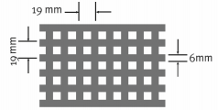
• Vinyl Ester Rein (V) ASTM E-84 Fire Rating Class A, 25 or less
Top Surface:
FRP grating is provided with an antiskid Grit (G) surface as standard.
This is a coarse grit that is embedded into the top surface of the grating. A plain top surface is available on request.
Treatment/Colour:
• Green (G) – Isopthalic Polyester Resin or
• Yellow (Y) – Vinyl Ester Resin
*NB. Mini Mesh is only available in 38mm deep bars
* Aperture is 12x 12mm
• Dark Grey (D) – Mini Mesh only
• Others colours available on request
Panel Size:
The standard range of panel size is shown below:
Code Panel Size
1 1220 x 3660

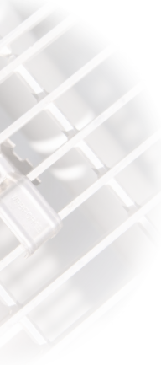
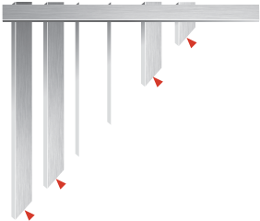
FRP Grating
FRP Load Table
G 256 I G G 1
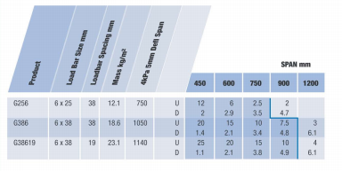
1 = 1220 x 3660
Panel Size

G = Green
U (kPa)
D (mm)
Treatment/Colour
Y = Yellow
D = Dark Grey

Top Surface
G= Grit
P = Plain
785
990
Material I = Isopthalic Polyester
V = Vinyl Ester
1035
15 10 4 2.5 2.5 1.6 4.1 4.1 5.1 15.3
15 15 10 5 2.5 1.0 2.4 3.7 3.8 5.9
15 15 10 7.5 2.5 1.0 2.4 3.6 4.7 4.8
Bar Size 256
386
U = Uniformly Distributed Load in kPa D = Deflection in mm
38619 (refers to Minimesh)
Pattern G = FRP


8



FRP Grating

Webforge FRP Grating - Chemical Resistance Table


%
Concentration
Vinyl Ester
Isophthalic
CHEMICAL
ENVIRONMENT
ºC
TEMP
ENVIRONMENT Concentration TEMP Ester
CHEMICAL % ºC Vinyl Isophthalic

Acetic Acid | 25 | MAX | C | C
Acetic Acid | 50 | MAX | C | C
Aluminum Hydroxide | ALL | MAX | C | C
Ammonium Chloride | ALL | 48.8 | C | C
Ammonium Bicarbonate | 15 | 48.8 | C | C
Ammonium Bicarbonate | 50 | 48.8 | C | C
Almmonium Hydroxide | 20 | 26.6 | S | N
Ammonium Sulfate | ALL | 488 | C | C
Benzene | 100 | 65.5 | I | I
Benzoic Acid (SAT) | SAT | MAX | C | C
Borax (SAT) | SAT | MAX | C | C
Calcium Carbonate | ALL | MAX | C | C
Calcium Nitrate | ALL | MAX | C | C
Carbon Tetrachloride | 100 | 26.6 | I | N
Chlorine, Dry Gas * | ALL | MAX | C | C
Chlorine Water (SAT) | SAT | 48.8 | C | I
Chromic Acid | 50 | 65.5 | I | N
Citric Acid | ALL | MAX | C | C
Copper Chloride | ALL | MAX | C | C
Copper Cyanide | ALL | 60 | C | S
Copper Nitrate | ALL | MAX | C | C
Ethanol | 10 | 488 | C | S
Ethanol | 50 | 488 | C | I
Ethylene Glycol | ALL | 65.5 | C | C
Ferric Chloride | 100 | MAX | C | C
Ferrous Chloride | ALL | MAX | C | C
Formaldehyde 0-50% | 50 | 48.8 | S | I
Gasoline | ALL | 48.8 | C | C
Glucose | ALL | 48.8 | C | C
Glycerin | 100 | MAX | C | C
Hydrobromic Acid | 50 | MAX | S | S
Hydrochloric Acid | 10 | MAX | C | S
Hydrochloric Acid | 37 | MAX | I | S
Hydrogen Peroxide | 30 | 26.6 | C | N

Lactic Acid 100 MAX C C
Lithium Chloride (SAT) SAT MAX N N
Magnesium Chloride ALL MAX C C
Magnesium Nitrate ALL MAX C C
Magnesium Sulfate ALL MAX C C
Mercuric Chloride ALL MAX C C
Mercurous Chloride ALL MAX C C
Nickel Chloride ALL MAX C C
Nickel Sulfate ALL MAX C C
Nitric Acid 20 48.8 S S
Oxalic Acid ALL 65.5 C C
Perchloric Acid 30 32.2 S I
Phosphoric Acid 80 MAX C C
Potassium Chloride ALL MAX C C
Potassium Dichromate ALL MAX C C
Potassium Nitrate ALL MAX C C
Potassium Sulfate ALL MAX C C
Propylene Glycol ALL MAX C C
Sodium Acetate ALL MAX C C
Sodium Bisulfate ALL 26.6 S S
Sodium Bromide ALL 26.6 C C
Sodium Cyanide ALL 26.6 C I
Sodium Hydroxide 10 MAX C I
Sodium Hydroxide 50 MAX S N
Sodium Nitrate ALL MAX C C
Sodium Sulfate ALL MAX C C
Sulfuric Acid 10 MAX C S
Sulfuric Acid 25 MAX C S
Sulfuric Acid 75 37.7 C I
Tartaric Acid ALL MAX C C
Vinegar ALL MAX C C
Water, Distilled ALL MAX C C
Zinc Nitrite 100 MAX C C
Zinc Sulfate 100 MAX C C
C = Continuous exposure of the grating to the Chemical Environment listed at the temperature listed
S = Frequent exposure of the grating to splashes and spills the Chemical Environment listed with that environment at the temperature listed
I = Infrequent Exposure of the grating to splashes and spills from the Chemical Environment listed with that environment at the temperature listed and the spill immediately cleaned up or washed from the grating .
N = Not recommended for the concentrations and temperatures listed
T =Test
MAX = indicates temperature of 85ºC for molded VinyI Ester . 71ºC for moulded Isopthalic grating.
ALL = All concentrations SAT = Saturated solution




9


Stair Treads

Steel
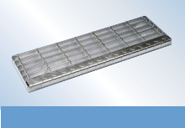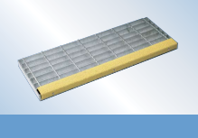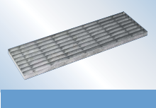

T3 – Welded Fixing, Floor plate Nosing

T5 – Welded Fixing, Abrasive Nosing

T1 – Welded Fixing, No Nosing
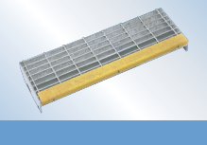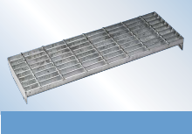
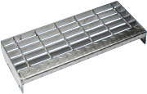
T4 – Bolted Fixing, Floor plate Nosing

T6 – Bolted Fixing, Abrasive Nosing

T2 – Bolted Fixing, No Nosing

Aluminium
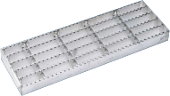
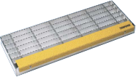
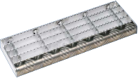

T3 – Welded Fixing, Floor plate Nosing
T5 – Welded Fixing, Abrasive Nosing
T1 – Welded Fixing, No Nosing
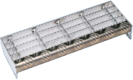
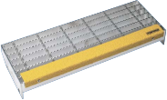
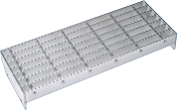

T4 – Bolted Fixing, Floor plate Nosing
T6 – Bolted Fixing, Abrasive Nosing
T2 – Bolted Fixing, No Nosing
AS1657 requires that the nosing of the tread is clearly visible against the background.

FRP
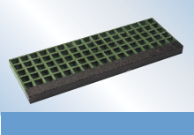

Bolted Fixing, Abrasive Nosing
Also available in Mini Mesh.

10



Stair Treads

The tables below indicate the maximum width and length for stair treads, depending on the
combination of material, pattern and load bar selected. Standard stair treads are available ex-stock
from Webforge locations; these standard profiles are complimented by a custom manufacturing service.


25 x 5
550
40 x 5
1600
1500
1350
40 x 5
1275
1050
700
32 x 5
1300
1200
850
25 x 6
32 x 5
900
675
450
38 x 6
25 x 5
900
750
550
-
-
-
-
-
-
-
-
875
600
-
-
-
-
-
-
Steel Aluminium FRP
Load Bar Size A & B Pattern C & D Pattern F Pattern
G Pattern

Recommended Maximum Tread Widths for Grating Patterns
Recommended Maximum Lengths for Grating Patterns

A & B Pattern  C & D Pattern F Pattern | 125  125  125 | 155  165  - | 185  -  185 | 215  205  - | 245  245  245 | 275  285  - | 305  325  305
G Pattern | - | - | - | - | 234 | 272 | 310

End Plates

The standard tread end plates for the different width stair treads are shown below. Tread end plates are manufactured from 65 x 5 For load bars > 40mm depth, special end plates are required.
flat bar.
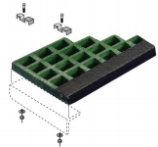
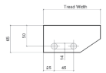
125mm Tread Widths
40mm minimum recommended bearing surface
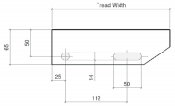
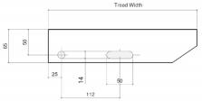

Standard FRP Treads

Top Saddle: C129SM
Screw: C301SM
25
4 clips per tread (angle not supplied)

4 clips per tread (angle not supplied)
75
Attach with:
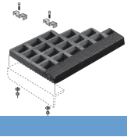
155, 165, 185mm Tread Widths 205,

215, 245, 275, 285, 305 & 325mm Tread Widths
Note: All end plates sniped at 34° unless requested otherwise
Drilling Stringers:

Please find below a table of recommended stair stringer hole centres.

Table of recommended stair stringers drilling for M12 bolts
40mm minimum recommended bearing surface

Minimesh Treads
Predrill angle with 7.4 Hole Attach with: Disc C140SM
4 clips per tread (angle not supplied)
Predrill angle with 7.4 Hole Attach with: Disc C140SM
Top Saddle: C129SM
Thread Rolling Screw: C309SM
Thread Rolling Screw: C309SM
4 clips per tread (angle not supplied)

Tread width mm Recommended stringer Hole size
hole centres mm mm
125 | 45 | 14 dia
155, 165, 185 | 75 | 14 dia
205, 215 | 100 | 14 dia
245, 275, 285, 305, 325 | 125 | 14 dia




11



Mild Steel

Fixing Clips
CLIP SET CODE
PATTERN
COMPRISES
USAGE
Top clip C100MG Bottom C200MG
M8 x 65mm Bolt C304MG
Mild Steel Grating Depth = <50mm Flange present

Stainless Steel & Aluminium Grating Depth = <50mm
Flange Present
C001MG
A - F

DESCRIPTION

Clip Set
Mild steel Galvanised Top, Bottom & Bolt
Aluminium

FRP
Top Clip C100SM Bottom C200SM M8 Bolt C301SM

Top Clip C129SM M8 Bolt C301SM
C001SM
A - F
Clip Set
Stainless Steel
Top, Bottom & Bolt
FRP Grating
Depth = 25mm & 38mm
C030SM
G
Mini Mesh
Top Disc C140SM
M8 x 65mm Bolt C309SM
FRP Grating
Depth = 38mm
C033SM
Clip Set
Stainless Steel Top & Bolt

Clip Set
Mini Mesh
Stainess Steel Top & Bolt


12



Fixing Clips

CLIP ASSEMBLIES
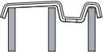

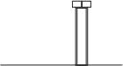
Plan View
D



TOPS
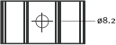
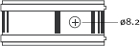

12

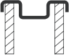
C140SM
Discwasher

BOTTOMS


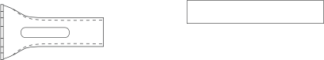
SCREWS/RIVETS


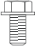
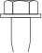



C309SM (65 x 8)
C308MG (50 x 8)
(Pilot Hole 7.4mm)
Thread Rolling.
Web Plate
WELDING

CLIP FREQUENCY
Nominal 4 panel, or 4 per m2, whichever is greater.
(Approximately 3 per M2 where span is >1500mm.
Fixing clips are generally not recommended in areas of vibration or where lateral or cantilever loads are applied to the grating.




13


Manufacturing Tolerances


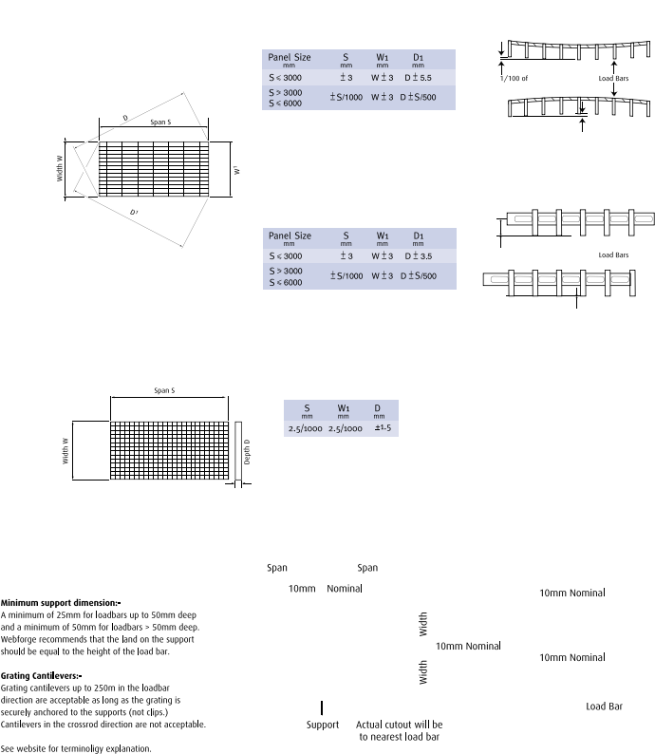


width

1/100 of width

1/200 of width

1/200 of width

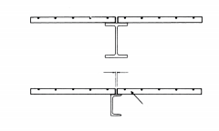

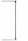


14

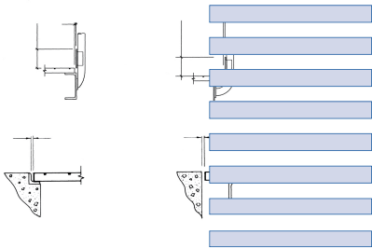
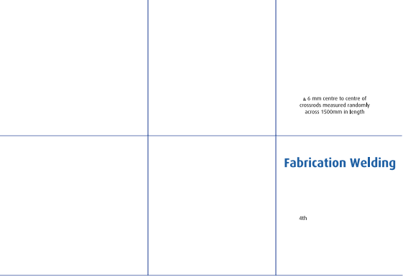

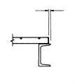
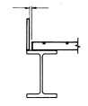
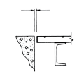

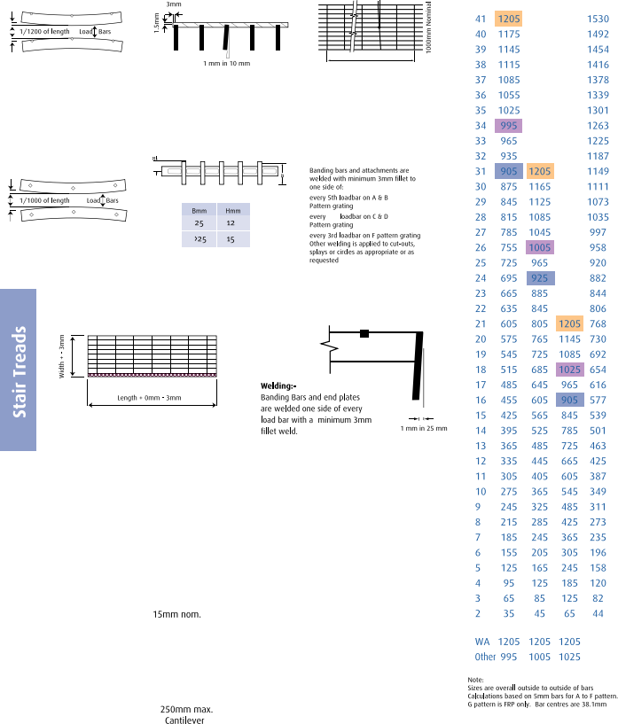
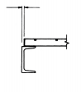
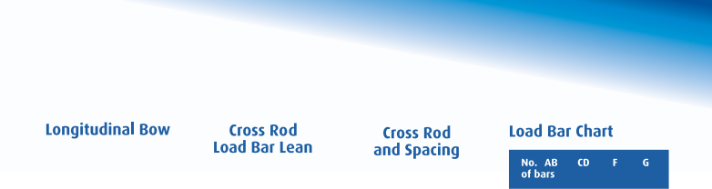

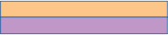
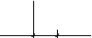





15



Accessories

Webplate
Any steel or aluminium grating pattern can be combined with any floorplate thickness. However Webforge recommends the use of Pattern F grating. Other combinations can be supplied on request.
Webplate is a flooring product that comprises floorplate welded to the top of the grating.

Webplate is available in the following steel or aluminium combinations

Material | Product | Floor  Treadplate  Thickness | Grating | Weight  Untreated  Kg/sqm | Span at 4kPa UDL  5mm  Deflection
STEEL | WP3 F255MP* | 3mm | F255MP* | 44.49 | 1390mm
 | WP5 F325MP* | 5mm | F325MP* | 64.78 | 1625mm
ALUMINIUM | WP3 F255AP* | 3mm | F255AP* | 16.21 | 1100mm
 | WP5 F325AP* | 5mm | F325AP* | 23.21 | 1350mm
Where *indicates treatment, refer to the website for a detailed description of part number protocols under steel and aluminium grating sections.


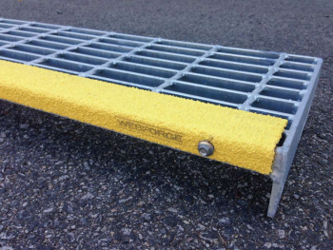
WebGripTM Anti-Slip
Available in:
• WebGripTM Anti-Slip Stair Nosing
• WebGripTM Metal Plating
• WebGripTM Metal Strips
• WebGripTM Conveyor Channel

Features:
• High Impact Resistance
• Anti-Slip Properties which overcome wet & oily surfaces
• Chermical & UV Resistance
• Durable Galvabond, Stainless Steel or Aluminium backing
• AS/NZ Certified

Stock sizes & Custom Manufactured sizes available

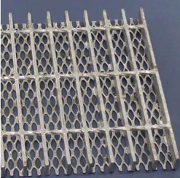
Webmesh
Webmesh comprises grating with a flattened, light gauge,
expanded mesh welded to the underside to prevent tools and small objects from falling through the grating.

Meets the requirements of AS/NZS1657 Clause 4.5 with mesh 1216F for steel grating or 1216AF for aluminium grating,
welded to the underside of the grating.

* See website for more details.


16

